- Harshit Singh__Computer Architecture
- Introduction
- In computer engineering, computer architecture is a set of rules and methods that describe the functionality, organization, and implementation of computer system ….in other definations computer architecture involves instruction set architecture design, microarchitecture design, logic design, and implementation.
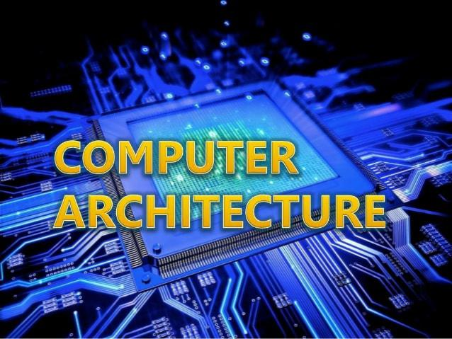
  - OVERVIEW AND INSTRUCTIONS

Embedded Computer: Performs single function on a microprocessor.
- Embedded within a product (e.g. microwave ,car, cellphone)
- Objective: Low cost
- Increasingly written in a hardware description language, like Verilog or VHDL
- Processor core allows application-specific hardware to be fabricated on a single chip.
Desktop Computer: Designed for individual use
- Also called personal computer, workstation.
Server: Runs large, specialized program (s)
- Shared by many users: more memory, higher speed, better reliability
- Accessed via network using a request-response (client-server) interface
- Example: File server, Database server, Web server.
Supercomputer: Massive computing resources and memory
- Hundreds to thousands of processors within single computer
- Terabytes of memory
- Program uses multiple processors simultaneously
- Rare due to extreme expense
- Applications: Weather forecasting, military simulation,etc.
What types of applications are concerned about:
- Memory?
- Processing speed?
- Usability?
- Maintainability?
How can the following impact performance?
- A selected algorithm?
- A programming language?
- A complier?
- An operating system?
- I/O system/devices?
Computer achitect must balance speed and cost across the system
- System is measured against specification
- Benchmark program measure performance of systems/subsystems
- Subsystems are designed to be in balance between each other
Usage:
- Normal: Data communication,time,clock frequencies
- Power of 2 : Memory (often)
Memory units:
- Bit (b): 1 binary digit
- Nibble: 4 binary digits
- Byte (B) : 8 binary digits
- Word: Commonly 32 binary digits ( but may be 64).
- Half word: Half the binary digits of a word
- Double word : Double the binary of a digits of a word
Common ues:
- 10 Mbps =10 Mb/s = 10 Megabits per second
- 10 MB = 10 Megabytes
- 10 MIPS = 10 Million Instructions per second

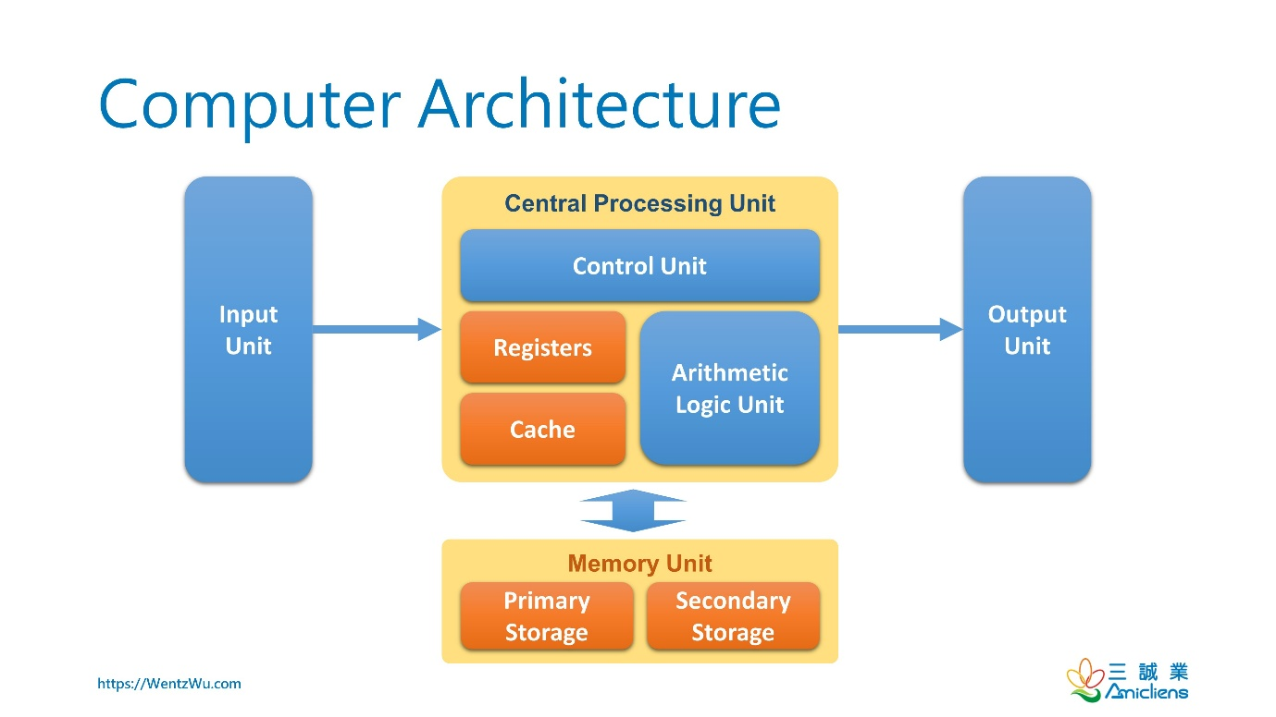
  - Moore’s law:
- Component density increase per year: 1.6
- Processor performance increase : 1.5 more recently 1.2 and <1.2
- Memory capacity improvement: 4/3:1.33
Tradeoffs in power versus Clock rate
- Faster Clock Rate = Faster Processing = More Power
- More Transistors = More complixty = More Power
  - 8 Great Ideas
- Design for Moore’s law
- Use abstraction to simplify design
- Make the common case fast
- Performance via parallelism
- Performance via pipelining
- Performance via pridictions
- Hierchy of Memories
- Dependability via redundancy
  - Components of a Computer System
Computer components include:
Input: Keyboard, Mouse, network, disk
Output: printer, video screen, network, disk
Memory: DRAM, magnetic disk
CPU: Intelligence: Includes Datapath and control
1.5 Input/Output
- Mouse:
Electromechanical: Rolling ball indicates change in position as (x,y) coordinates.
Optical: Camera samples 1500 times per second. Optical processor compares images and determines distance moved.
- Displays:
Raster Refresh Buffer: Holds the bitmap or matrix of pixel values.
Matrix of pixels : low resolution: 512×340 pixels to high resolution: 2560×1600 pixels
Black & White : 1 bit per pixel
Grayscale : 8 bits per pixels
Color: (one method): 8 bits for each red, blue, green =24 bits
Required: Refresh the screen periodically to avoid flickering
Two types of Displays:
Cathode Ray Tube (CRT): Pixel is source of light

Scans one line at a time with a refresh rate of 30-75 times per second
Liquid Crystal Display (LCD): LCD pixel control or bends the light for the display.

Color active matrix LCD: Three transistor switches per pixel
Networking: Communications between computers
Local Area Network (LAN): A network which spans a small area: within a building
Wide Area Network (WAN): A network which extends hundreds of miles; typically managed by a communication service provider

Memory Hierchy:
[ register]<—>[Cache]<—>[Main memory]<—>[Magnetic disk]<—>[Tape]
Fast, expensive, volatile. Slow, cheap, non-volatile

Secondary memory: Non-volatile memory used to store programs and data when not running
Non-volatile: Does not lose data when powered off
Includes:
Magnetic Disk: Access time: 5-15 ms
Tape: Sometimes used for backup
Optical Disk: CD or DVD
FLASH: Removable memory card attach via USB
Floppy and Zip: Removable form of magnetic disk

Magnetic Disk: Movable arm moves to concentric circle then writes

Disk diameter: 1 to 3.5 inches
Latency: Moving head to _cylinder’ or concentric track
Rotation Time: Rotating cylinder to correct location on _track’
Transfer Time : Reading or writing to disk on _track’
Access time : 5-20 ms

Optical Disk: Laser uses spiral pattern to write bits as pits or flats.

Compact Disc (CD): Stores music
Digital Versatile Disc(DVD): Multi-gigabyte capacity required for films read-write procedure similar to Magnetic Disk (but optical write, not magnetic)

Flash Memory: Semiconductor memory is non-volatile
- More expensive than disk, but also more rugged and faster latency.
- Good for 100,000-1M writes.
- Common in cameras, portable music players, memory sticks

Primary or Main Memory: Program are retained while they are running.Uses:

Dynamic Random Access Memory (DRAM): Built as an integrated cir6, equal speed to any location in memory access tome :50-70 ns.
SIMM (Single in-line memory module):DRAM memory chips lined up in a row, often on
A daughter card
DIMM (Dual in-line memory Module): Two rows of memory chips ROM
(Read only memory) or EPROM (Erasable Programmable ROM)

Cache: Buffer to the slower, larger main memory. Uses:
Static Random Access Memory (SRAM)
Faster, less dense and more expensive than DRAM
Uses multiple transistors per bit instead of the single transistor for DRAM

Register: Fastest memory within the CPU.

Central Processing Unit (CPU) or Processor: Intelligence

Data Path: Performs arithmetic operations using registers
Control: Management of flow of information through the data path
BUS: Connects the CPU, Memory ,I/O Devices

Bits are transmitted between the CPU, Memory. I/O Devices in a timeshared
Way serial buses transmit one bit at a time.
Parallel buses transmit many bits simultaneously on same bus
One bus: CPU <—> Memory
One bus: CPU <—> I/O Subsystem
Example: Universal serial bus (USB 2.0)
Hot-pluggable: Can be plugged unplugged without damage to the ststem
Operates at 0.2, 1.5 or 60 MB/sec
Can interface to printer or other slow devices.

  - Technology
Year | Technology used in computers | Relative performance/unit
1951 | Vacuum tube | 1
1965 | Transistor | 35
1975 | Integrated circuit | 900
1995 | Very large-scale integrated circuit | 2,400,000
2005 | Ultra large-scale integrated circuit | 6,200,000,000

A transistor is simplify an on/of switch controlled by electricity. The integrated circuit (IC)
Combined dozens to hundreds of transistors into a single chip. To describe the tremendous
Increase in the number of transistors from hundreds to millions, the adjective very large scale is added to the term, creating the abbreviation VLSI , for very large-scale integrated circuit.

1.6. Classes of Computers
Desktop computers
- Designed to deliver good performance to a single user at low cost usually executing 3rd
Party software, usually incorporating a graphics display, a keyboard, and amouse
Servers
- Used to run larger programs for multiple, simultaneous users typically accessed only via a Network and that places a greater emphasis on dependability and (often) security.
- Modem version of what used to be called mainframes, minicomputers and supercomputers.
- Large workloads
- Built using same technology in desktop but higher capacity
- Gigabytes to Terabytes to Petabytes of storage
- Expandable
- Scalable
- Reliable
- Large spectrum: from low-end (file storage, small businesses) to supercomputers (high and scientific and engineering applications) Examples: file servers, web servers, database.
  - Supercomputers
- A high performance, high cost class of server with hundreds to thousands of processors, Terabytes of memory and Petabytes of storage that are used for high-end scientific and engineering applications.
1.7. Embedded Computers (processors)
- A computer inside another device used for running one predetermined application.
  - Microprocessors everywhere! (Washing machine, cell phones, automobiles, video games)
  - Fun one or a few applications
  - Specialized hardware integrated with the application (not your common processor)
  - Usually stringent limitations (battery power)
  - High tolerance for failure (don’t want your airplane avoinces to fail! )
  - Becoming ubiquitous
  - Engineered using processor cores
  - The core allows the engineer to integrate other functions into the processor for fabrication on the same chip .
  - Using hardware description languages: Verilog, VHDL
  - Embedded processor characteristics
The largest class of Computers spanning the widest range of applications and performance.
Often have minimum performance requirements.
Often have stringent limitations on cost.
Often have stringent limitations on power
Consumption. Often have low tolerance for failure.

1.8. Performance and Powerwall
Purchasing perspective
- Given a collection of machines, which has the
- Best performance ?
- Least cost ?
- Best cost / performance?
- Design perspective
Faced with design options, which has the
- Best performance improvement ?
- Least cost ?
- Best cost/performance ?
- Both require
- Basic for comparison
- Metric for evaluation
- Our goal is to understand what factors in the architecture contribute to overall system performance and the relative importance (and cost) of the factors.
  - Performance
Defining performance
Let’s suppose we define performance in terms of speed. This still leaves two possible definitions. You could define the fastest plane as the one with the highest cruising speed, taking a single passenger from one point to another in the least time. If you were interested in transporting 450 passengers from one point to another, however, the 747 would clearly be the fastest, as the last column of the figure shows. Similarly, we can define computer performance in several different ways.

Airplane | Passenger capacity | Cruising range(miles) | Cruising speed(m.p.h.) | Passenger through (passenger×m.p.h.)
Boeing 777 | 375 | 4630 | 610 | 228,750
Boeing 747 | 470 | 4150 | 610 | 286,700
BAC /sud  Concorde | 132 | 4000 | 1350 | 178,200
Douglas DC-8-50 | 146 | 8720 | 544 | 79,424

1.9 Summary for Computer Architecture :
- Computer architecture represent the means of interconnectivity for a computer’s hardware components as well as the mode of data transfer and processing exhibited…. The basic architecture has the CPU at the core with a main memory and input/output system on either side of the CPU.
2.0 Future work of Computer Architecture :
- Computer architecture is a field which aims to enhance the performance of processors, either through software or hardware, be it a DSP, GPU or application specific processor. It is a wide field and has got plenty of opportunities associated with it.
Let me discuss each of them.
Firstly, the hardware part. You can be there building and designing one of the processor blocks like fetch stage or executive stage of a processor. Many people are involved in development of memory hierarchies as well as floating point units.
Companies like Intel, Qualcomm, Broadcomm, ARM build their own processors. Once a significant part of RTL is done, design and verification (DV) team is set up to check the functional correctness of the RTL. Many such jobs are outsourced in India. Companies like NVidia develop GPU’s, which consist of a large number of streaming multiprocessors, each one of them goes through
The same cycle.
Secondly, on the software side, your knowledge of data structures can help. Concurrent DS are new areas of programming, which deals with algorithms that can figure out maximum parallelism to run all the processors Simultaneously. Building compilers that produce optimized code is also a part of the same.

Digital VLSI is a good career choice and goes well with computer architecture. Comp. Arch. Is usually called the front end team and after they finish most of their task, it is transferred to the back end team for VLSI work, which includes, but not limited to, floor-planning, timing analysis, low-power verification etc. Lot of opportunities are available in those field too.

Subjects selection for the career many include
Digital IC Design
Advance Computer Architecture
VLSI Design
Etc..

****************************** The end *****************************

- Sub = IT Project Work
- Class= 9th ‘D’
- Date= 01/October/2021
- Topic= Computer Architecture
- Name= Harshit Singh
- Subject teacher= Praveen Joshi, sir

***************************** Thankyou ***************************

.

